ResolveNow: Online Complaint Registration and Management System

# Team Members

Varanasi Rahul  
Chilukuri Sri Lakshmi  
Chintalapati Vamsikrishna  
Bhargav Dokala  
Madanaboyana Sai Saranya

# Abstract

ResolveNow is an online complaint registration and management system designed to streamline the process of submitting, tracking, and resolving user complaints. It features user registration, real-time status tracking, secure communication with assigned agents, and intelligent complaint routing. Technically, the platform uses React.js and Material UI for the frontend, Express.js and Node.js for the backend, and MongoDB for database management, forming a robust and scalable full-stack web application.

# Introduction to Complaint Management Platforms and ResolveNow

Online Complaint Registration Systems provide a centralized platform for organizations to manage customer complaints efficiently. ResolveNow exemplifies this by offering a full-stack solution for users to report, track, and resolve complaints in real-time, with security, usability, and scalability at its core.

# Project Overview: ResolveNow Core Features

ResolveNow delivers a powerful set of features including a user-friendly interface, complaint submission and tracking, real-time user-agent interaction, automated complaint routing, and robust data protection mechanisms. These features support customers, agents, and administrators throughout the resolution lifecycle.

# Scenario-Based Use Case: John’s Complaint Journey

John signs up on the ResolveNow platform and submits a complaint about a defective product. He receives real-time updates and interacts with an assigned agent who resolves the issue. The admin ensures smooth operation of the system, overseeing complaint assignment and progress.

# Functional Requirements

- User registration and login  
- Complaint submission with document upload  
- Complaint tracking and notifications  
- Real-time messaging with agents  
- Admin dashboard for complaint assignment  
- Security and data confidentiality measures

# Technical Architecture Overview

ResolveNow is structured on a client-server architecture using the MERN stack. React.js with Material UI and Bootstrap builds the responsive frontend. The backend, powered by Express.js and Node.js, handles logic and API routes. MongoDB ensures scalable data storage, while socket.io and WebRTC APIs support real-time features.

# Conclusion

ResolveNow offers a comprehensive and secure platform for complaint resolution. It improves operational efficiency, customer satisfaction, and compliance through a robust technical framework. Its modular and scalable design ensures adaptability for future feature integrations and user growth.

# Platform Interface Overview

Below are screenshots representing the visual flow of the ComplaintCare platform. These illustrate the homepage, login interface, and signup process as part of the user journey.

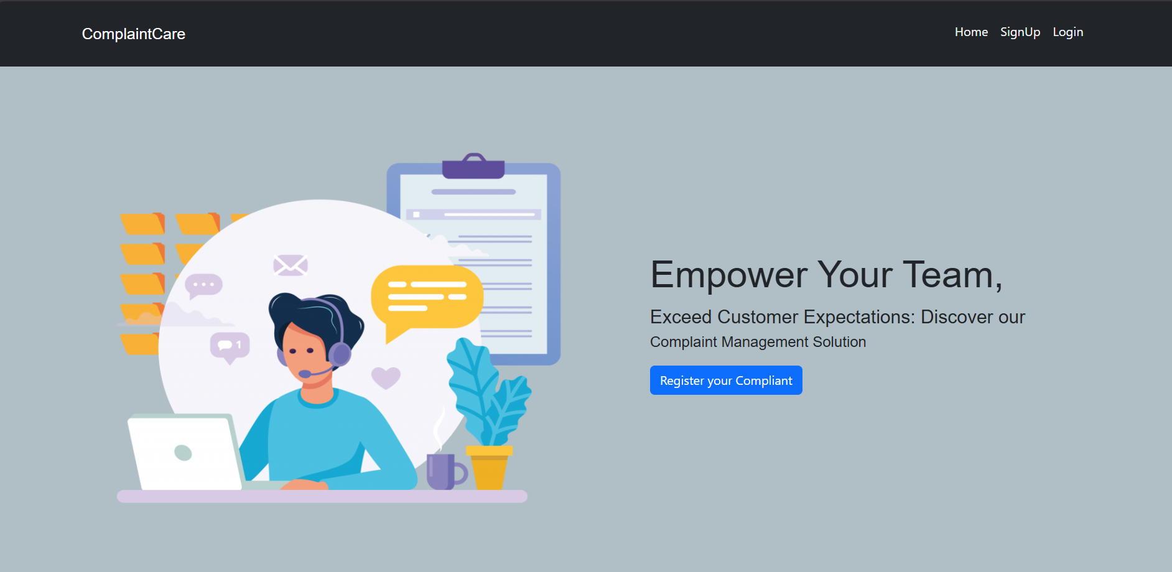

Homepage Interface - Empowering Users

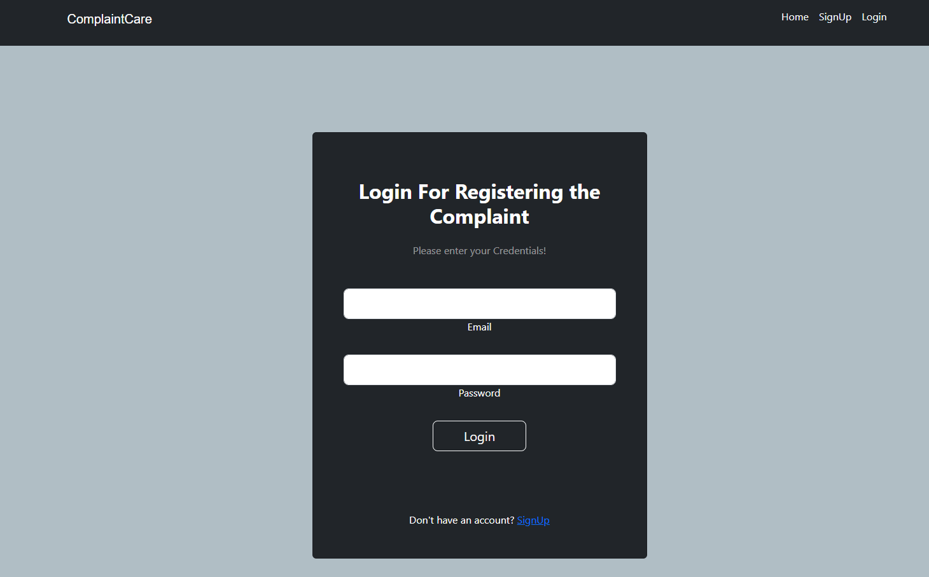

Login Interface - Secure User Authentication

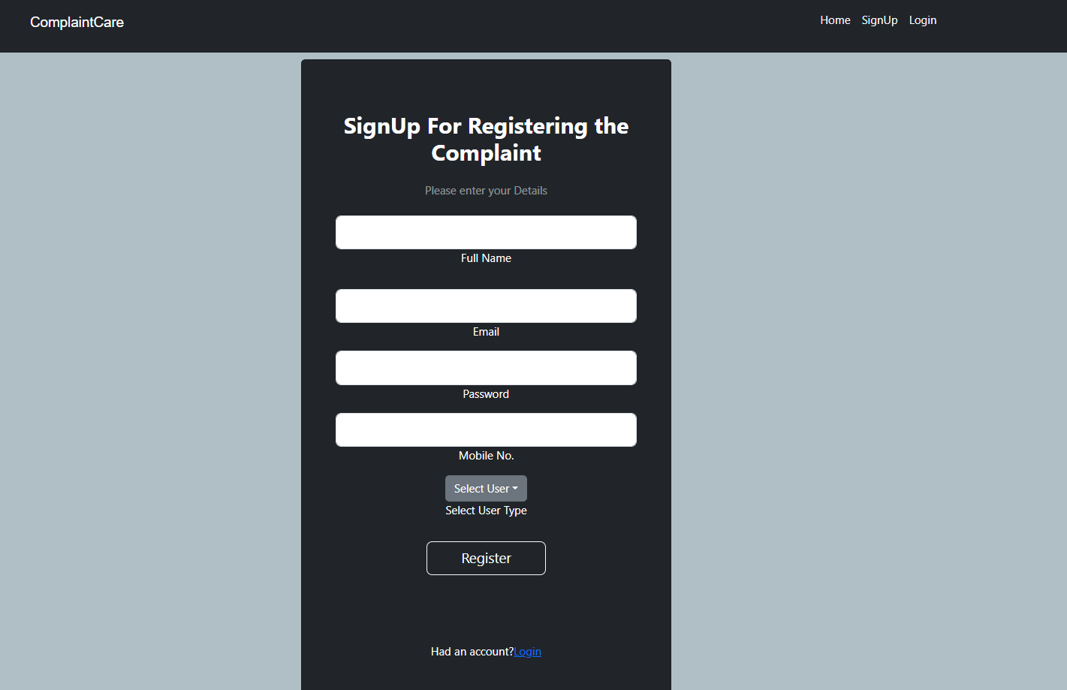

Signup Interface - New User Registration

# User Journey and Interaction Flow

The ResolveNow platform has been built to support a fluid user experience from registration to complaint resolution. Users sign up using secure credentials, access personalized dashboards, submit complaints, and monitor their progress. Interactions with agents are facilitated using real-time messaging tools integrated into the system, ensuring clear and prompt communication.

User types include general customers, complaint-handling agents, and administrators. Each role is assigned permissions using role-based access control. Admins have visibility across all user activities and are responsible for routing and monitoring complaint statuses. The design prioritizes clarity and responsiveness, offering seamless transitions and informative feedback throughout the process.

# Security Measures and Data Handling

The platform uses JSON Web Tokens (JWT) for secure authentication and authorization. Passwords are hashed using bcrypt, ensuring they are never stored in plaintext. Data exchange is encrypted with HTTPS protocols to prevent eavesdropping and unauthorized access.  
  
MongoDB’s flexible schema allows secure storage of user and complaint data. Collections are structured to segregate user roles, complaint logs, message exchanges, and progress indicators. Data backups and replication mechanisms are in place to preserve integrity and ensure high availability.

# Real-Time Technologies and Chat Feature

One of the standout features of ResolveNow is the integrated real-time communication. Socket.io is employed to facilitate instant updates and messaging between users and agents. This ensures that when a complaint status is updated, or a new message is received, it reflects immediately in the user interface.  
  
The platform also supports future integration of WebRTC for direct video calls between users and agents, which can enhance clarity in complex issue resolution scenarios.